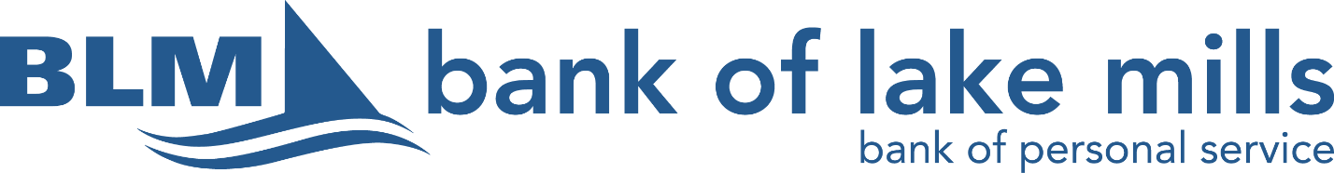

Bank of Lake Mills Committed to Community Scholarship
Bank of Lake Mills is committed to our community and wants to contribute to the continuing education efforts of students in the communities we serve. Each year we offer a $1,000 scholarship for a senior attending Lakeside Lutheran High School. The student who is awarded this scholarship will show that they are also committed to their community. This can be demonstrated in the 250-word essay along with history of community volunteering. Students are required to have completed at least 20 hours of volunteering in their high school career.

Scholarship Requirements:
- Student must be a graduating senior completing high school in the current year at Lakeside Lutheran High School.
- Student must be registered to attend as a full-time student at an accredited post-secondary educational institution located in the United States.
- Student must be in good standing and have a cumulative high school GPA of 2.5 or above.
- Student must have completed at least 20 hours of volunteering during their high school career.
- Students must submit an essay of 250 words or more describing how they spent time volunteering and the impact that has had on them and their community.

Bank of Lake Mills will select one scholarship winner from Lakeside Lutheran High School per academic year.
This scholarship will be paid in one installment during the student’s first academic year of post-secondary education. The scholarship is nonrenewable.
Bank of Lake Mills Committed to Community Scholarship

Name: _____________________________________________
Address: ___________________________________________
City:______________________ Phone: __________________

Cumulative GPA __________ Class Rank ______________
College or University _______________________________
Intended course of study _____________________________

On a separate sheet please explain in 250 words or more how you spent your time volunteering and how that has had an impact on you.

All applications must be turned in to Lakeside’s Guidance Office by Friday, March 29, 2024.

